Name :Bilal abid abbasi
ID:45961
Opp lab 06:

1. Inventory management system for retail store:
#include <iostream>
using namespace std;

class Product{
private:
int productID;
string name;
int quantity;
double price;

static int totalProducts;
public:
Product(){
productID = 0;
name = "Unknown";
quantity = 0;
price = 0.0;

totalProducts++;
}

Product(int pid,string name,int quantity,double p){
productID = pid;
this->name = name;
this->quantity = quantity;
price = p;

totalProducts++;
}

Product(Product &obj){
productID = obj.productID;
this->name = obj.name;
this->quantity = obj.quantity;
price = obj.price;

totalProducts++;
}

void setProductID(int pid){
productID = pid;
}
int getProductID(){
return productID;
}

void restock(int q){
if(q > 0){
quantity += q;
}else{
cout<<"Please Enter a valid Qty\n";
}
}

void sell(int q){
if(q <= quantity){
quantity -= q;
}else{
cout<<"You have only " <<quantity<<"\n";
}
}

void displayProduct() const{
cout<<"\n******ProdcutDetails******\n";
cout<<"Product ID: "<<productID<<endl;
cout<<"Name: "<<name<<endl;
cout<<"Price: "<<price<<endl;
cout<<"Qty: "<<quantity<<endl;
cout<<"\n*************************\n";
}

static int getTotalProducts(){
return totalProducts;
}

~Product(){
cout<<"Product # "<<productID<<" has been removed form here\n";
}
};

int Product::totalProducts = 0;

int main() {
Product p;
int totalProducts = Product::getTotalProducts();
p.displayProduct();
cout<<"Total Products: "<<totalProducts;
p.restock(50);
p.displayProduct();
p.sell(5);
p.displayProduct();

Product p2(100,"Tapal Danydar 1000g", 5012, 1800.00);
p2.displayProduct();
totalProducts = Product::getTotalProducts();
cout<<"Total Products: "<<totalProducts<<endl;

const Product p3(101,"Milk", 502, 90.00);
p3.displayProduct();
totalProducts = Product::getTotalProducts();
cout<<"Total Products: "<<totalProducts<<endl;
//p3.restock(2);
return 0;
}
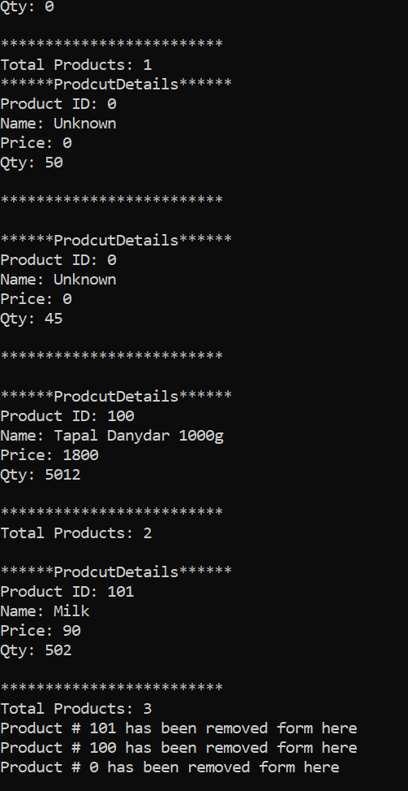

Output:

2.Library book management system

#include <iostream>
using namespace std;

class Book {
private:
const string ISBN;
string title;
bool isAvailable;

public:
Book(string isbn, string bookTitle, bool status)
: ISBN(isbn), title(bookTitle), isAvailable(status) {
cout << "Book \"" << title << "\" added to the library." << endl;
}

~Book() {
cout << "Book \"" << title << "\" with ISBN " << ISBN
<< " removed from the library." << endl;
}

void toggleAvailability() {
isAvailable = !isAvailable;
}

void display() const {
cout << "ISBN: " << ISBN
<< " | Title: " << title
<< " | Status: "
<< (isAvailable ? "Available" : "Checked Out")
<< endl;
}
};

int main() {
Book editableBook("123-ABC", "C++ Basics", true);
const Book recordBook("456-DEF", "Advanced Algorithms", true);

cout << "\n--- Non-Const Book ---" << endl;
editableBook.display();
editableBook.toggleAvailability();
editableBook.display();

cout << "\n--- Const Book ---" << endl;
recordBook.display();

return 0;
}

:
Output:
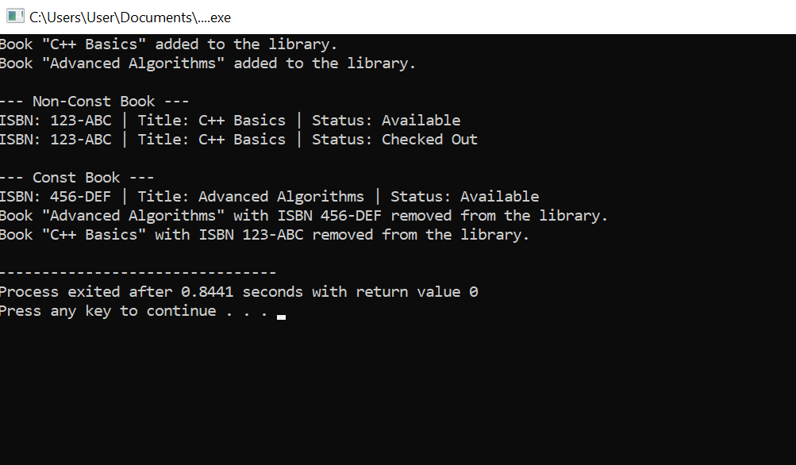

3.Employee attendance tracking system

#include <iostream>
using namespace std;

class Employee {
private:
const int empID;
string name;
int individualAttendance;
static int attendanceCount;

public:
Employee(int id, string n) : empID(id), name(n), individualAttendance(0) {
cout << "[System]: Employee " << name << " (ID: " << empID << ") registered." << endl;
}

~Employee() {
cout << "[System]: Employee " << name << " is leaving the system." << endl;
}

void markAttendance() {
individualAttendance++;
attendanceCount++;
cout << "Attendance marked for " << name << "." << endl;
}

void viewRecord() const {
cout << "ID: " << empID << " | Name: " << name
<< " | Individual Check-ins: " << individualAttendance << endl;
}

static int getTotalAttendance() {
return attendanceCount;
}
};

int Employee::attendanceCount = 0;

int main() {
Employee emp1(101, "Alice");
Employee emp2(102, "Bob");
Employee emp3(103, "Charlie");

cout << "\n--- Simulating Attendance ---" << endl;
emp1.markAttendance();
emp2.markAttendance();
emp1.markAttendance();
emp3.markAttendance();
emp2.markAttendance();

cout << "\n--- Employee Records ---" << endl;
emp1.viewRecord();
emp2.viewRecord();
emp3.viewRecord();

cout << "\nTotal System-wide Attendance: " << Employee::getTotalAttendance() << endl;
cout << "-----------------------------" << endl;

return 0;
}

Output:
